write three more examples like in this photo and also write two more examples with solutions
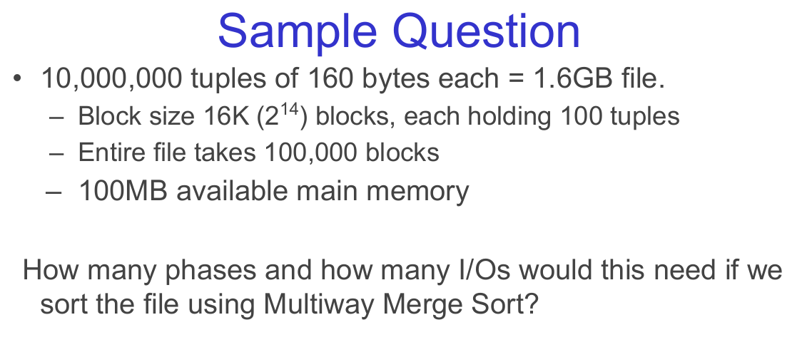
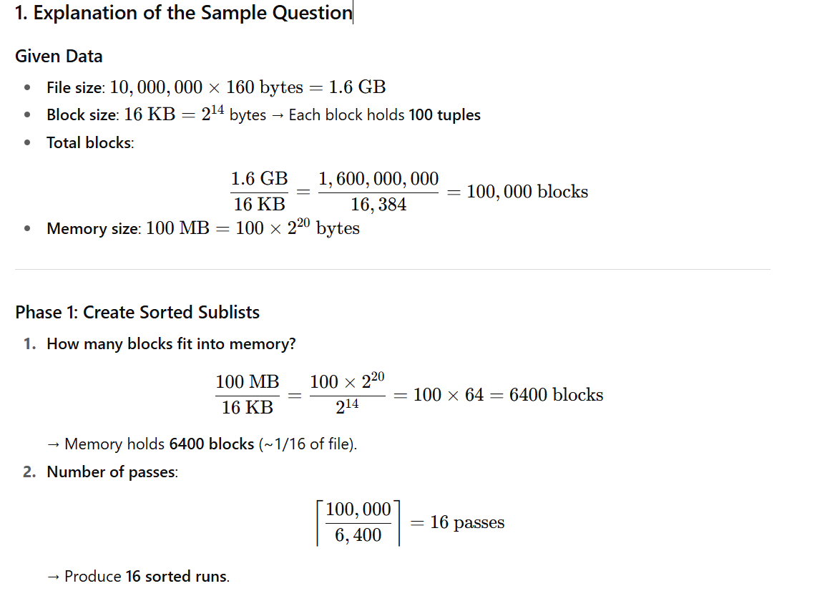

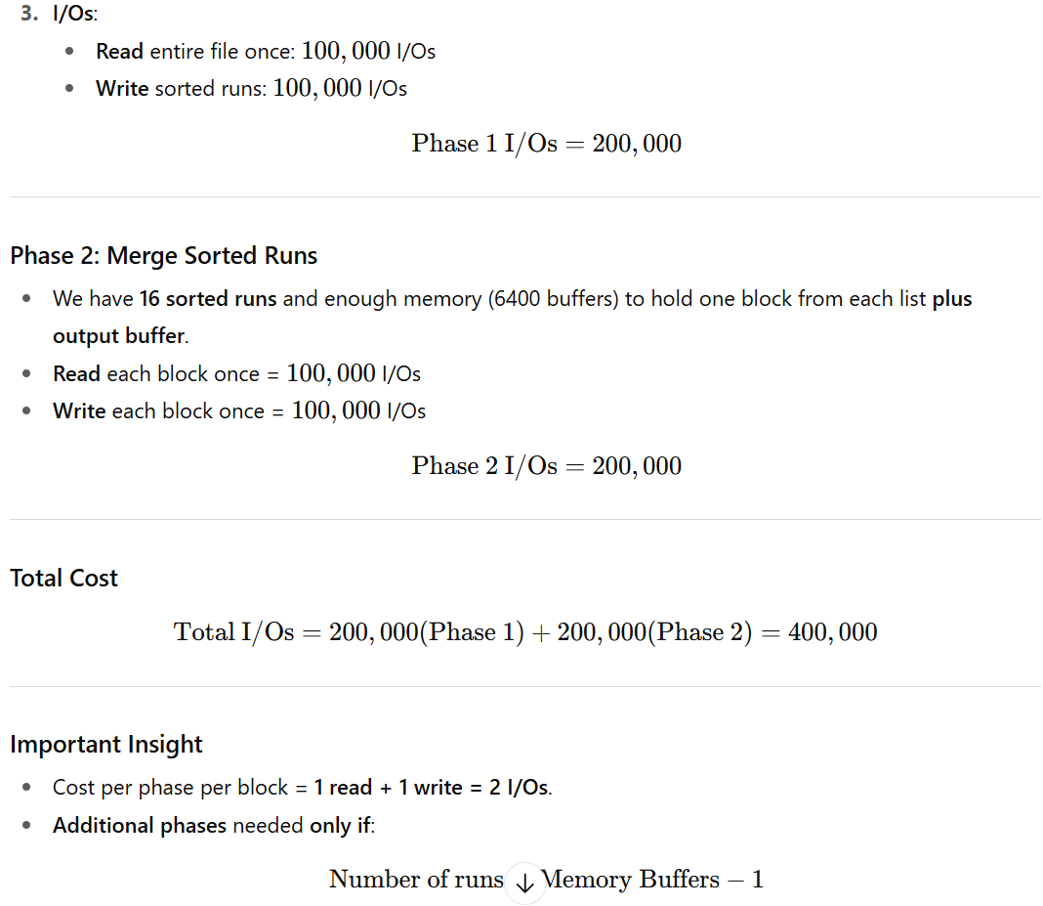
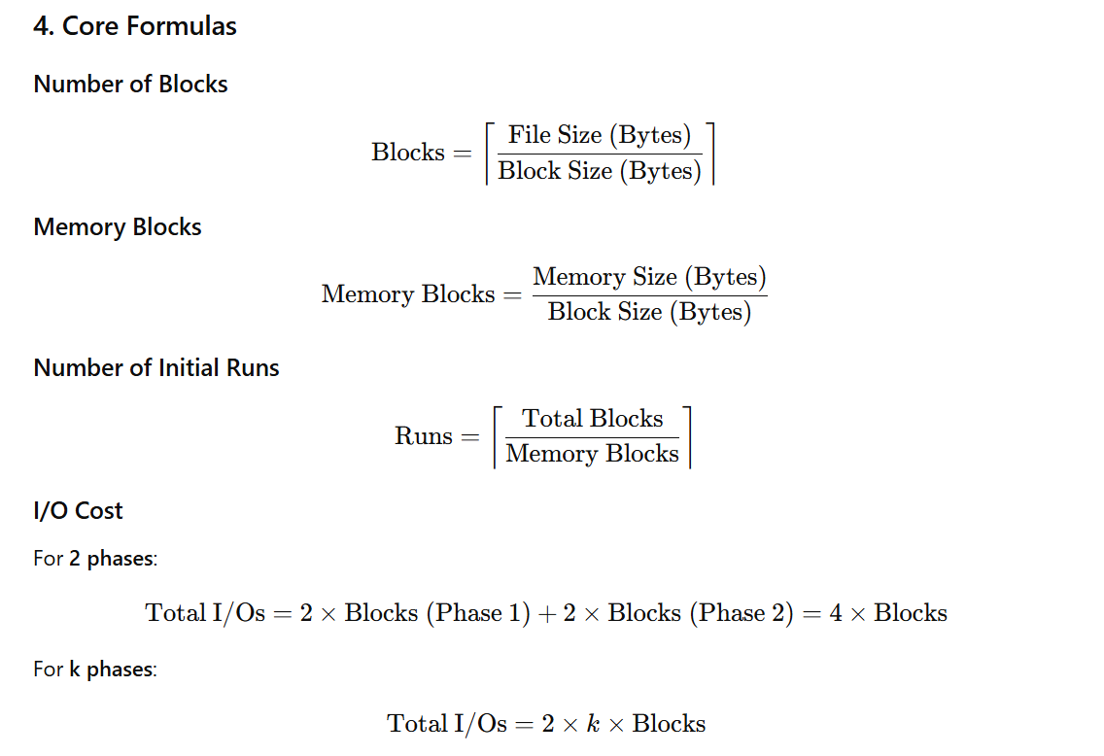

Practice Questions

1a. A 2.5GB file with 200B records, 4KB blocks, and 32MB memory:
  - Calculate blocks, memory buffers, number of runs, and total I/Os.

1b. Sort 1 billion records of 100B with 64KB blocks and 256MB memory:
  - Will it fit in 2 phases? Calculate phases and I/Os.

1c. How does doubling block size from 16KB to 32KB affect I/Os and transfer time?

2. Similar Practice Questions

Q1. Medium Dataset
A file has 5,000,000 records, each 200 bytes.
- Block size = 8 KB
- Available memory = 64 MB
Tasks:
- Calculate the number of blocks in the file.
- Calculate how many blocks can fit in memory.
- Determine the number of phases and total I/Os for multiway merge sort.
Soln:
- 12,208 blocks
- 8192 blocks
- 2 runs as phases; 4*12,208 = 48,832 I/Os

Q2. Large Memory Scenario
A file contains 20,000,000 tuples, each 150 bytes.
- Block size = 32 KB
- Available memory = 512 MB
Questions:
- How many sorted runs will Phase 1 produce?
- Will sorting finish in 2 phases, or is a third phase required?
- Calculate the total number of I/Os.

Q3. Larger Block Size Impact
For the original problem:
- Change block size from 16 KB to 32 KB.
- Transfer time for 16 KB = 0.13 ms, seek + latency = 10.63 ms.
Questions:
- Recalculate number of blocks.
- Estimate I/O time with 32 KB blocks.
- Explain why larger blocks reduce the number of I/Os but only slightly increase transfer time.

Q4. Memory-Constrained Sorting
A file is 2.5 GB, with 200-byte records and 4 KB blocks.
Available main memory is only 32 MB.
Questions:
- Calculate the number of blocks.
- Calculate blocks that fit in memory.
- Determine the number of passes required.
- Compute the total I/Os.

Q5. Very Large Dataset
A database table of 1 billion records, each 100 bytes, needs to be sorted.
- Block size = 64 KB
- Available memory = 256 MB
Questions:
- How many blocks does the file occupy?
- How many blocks fit in memory?
- Calculate the number of phases and total I/Os.
- Suggest optimizations to handle such large datasets efficiently.

Would you like me to solve one of these new questions step-by-step to show the calculation process clearly?

Exercise 1
Sample Question:
- Dataset: 20,000,000 tuples of 200 bytes each = 4GB file
- Block Details:
  - Block size 32K (2¹⁵), each block holds 160 tuples
  - Entire file takes 125,000 blocks
  - 200MB available main memory
How many phases and how many I/Os would be needed if we sort the file using Multiway Merge Sort?

Exercise 2
Sample Question:
- Dataset: 50,000,000 tuples of 128 bytes each = 6.4GB file
- Block Details:
  - Block size 8K (2¹³), each block holds 64 tuples
  - Entire file takes 781,250 blocks
  - 500MB available main memory
How many phases and how many I/Os would be needed if we sort the file using Multiway Merge Sort?

Exercise 3
Sample Question:
- Dataset: 5,000,000 tuples of 256 bytes each = 1.2GB file
- Block Details:
  - Block size 64K (2¹⁶), each block holds 250 tuples
  - Entire file takes 20,000 blocks
  - 50MB available main memory
How many phases and how many I/Os would be needed if we sort the file using Multiway Merge Sort?

Exercises with Solutions
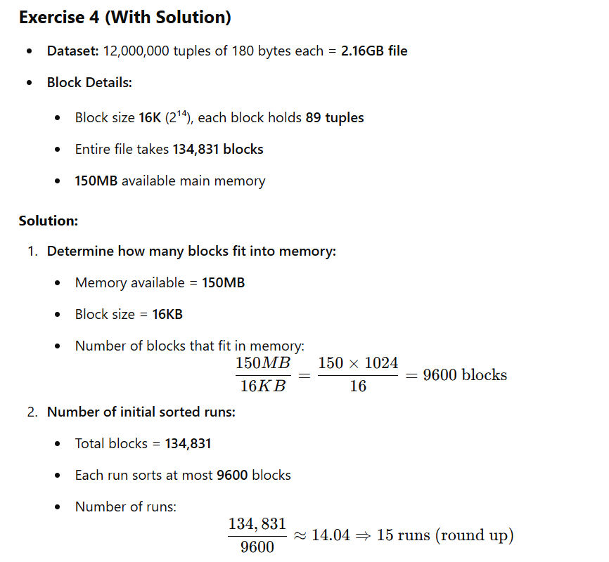
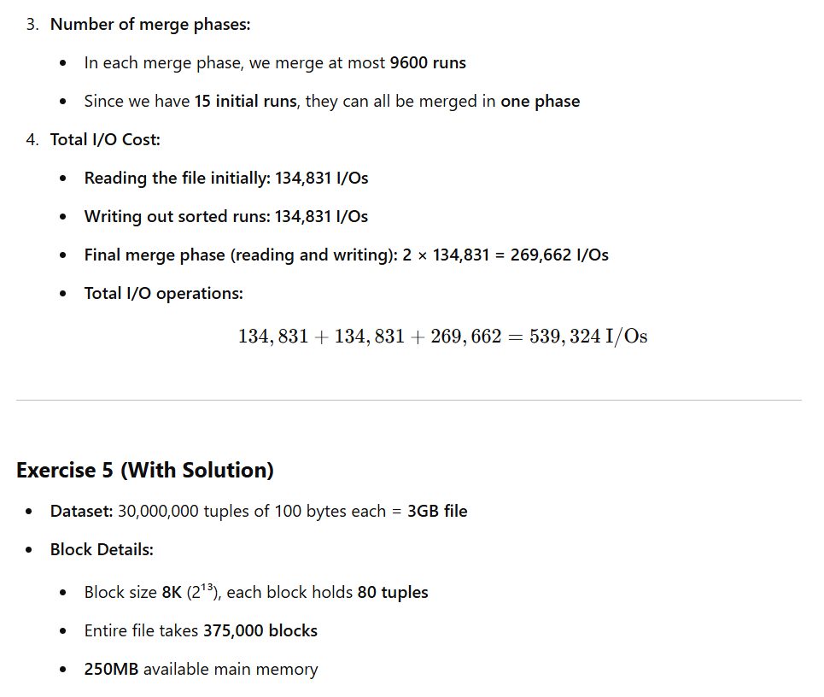

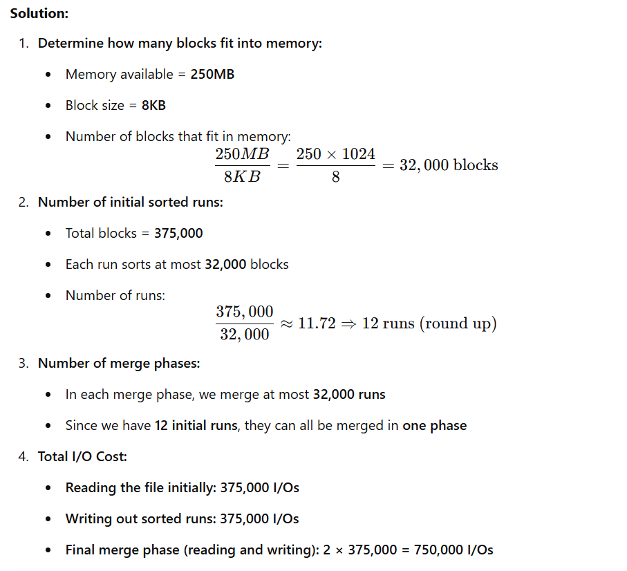
Total I/O operations: 375,000 + 375,000 + 750,000 = 1,500,000 I/Os
Here are two more similar sample questions (no solutions), each with parts a and b:
1)
• 20,000,000 tuples of 120 bytes each → file size = 2.4 GB.
• Block size = 8 KB (8192 bytes) — each block holds 68 tuples (approx).
• Entire file takes ≈294,118 blocks.
• Available main memory = 128 MB (≈16,384 blocks).
Question: If we sort the file using Multiway Merge Sort, how many phases are required and how many disk I/Os will the sort perform under these assumptions?
a) Now assume the main memory is reduced to 64 MB (half). How many phases and I/Os are needed?
b) Now assume block size is increased to 32 KB (32768 bytes) while returning memory to the original 128 MB. How many phases and I/Os are needed?
2)
• 5,000,000 tuples of 256 bytes each → file size = 1.28 GB.
• Block size = 4 KB — each block holds 16 tuples.
• Entire file takes ≈ 80,000 blocks.
• Available main memory = 40 MB (≈10,240 blocks).
Question: Using Multiway Merge Sort, determine the number of phases and total disk I/O cost (reads + writes) for sorting this file.

